**ARDUINO BASED REAL TIME DROWSINESS AND FATIGUE DETECTION FOR BIKERS USING HELMET**

##### A PROJECT REPORT

###### ***Submitted by***

|  |  |
| --- | --- |
| **ARUN KUMAR T** | **(110319106003)** |
| **DINESH BENJAMIN M V** | **(110319106010)** |
| **UMAPATHY A V** | **(110319106046)** |

***in partial fulfillment for the award of the degree***

***of***

**BACHELOR OF ENGINEERING**

*in*

# ELECTRONICS AND COMMUNICATION ENGINEERING



**GRT INSTITUTE OF ENGINEERING AND TECHNOLOGY**

**TIRUTTANI – 631 209**

**ANNA UNIVERSITY: CHENNAI 600 025**

**MAY – 2023**

**ANNA UNIVERSITY: CHENNAI 600 025**

**BONAFIDE CERTIFICATE**

Certified that this project report **“**ARDUINO BASED REAL TIME DROWSINESS AND FATIGUE DETECTION FOR BIKERS USING HELMET**”** is the bonafide work of **ARUN KUMAR T (1103119106003), DINESH BENJAMIN M V(110319106010)** and **UMAPATHY A V (110319106046)** who carried out the project work under my supervision.

|  |  |
| --- | --- |
| **SIGNATURE** | **SIGNATURE** |
| **Dr. P. SIVAKUMAR, M.Tech, Ph.D.,** | **Mr.V.SORNAGOPAL, M.E.,** |
| **HEAD OF THE DEPARTMENT** | **SUPERVISOR** |
| Professor | Associate Professor |
| Department of Electronics and Communication Engineering | Department of Electronics and Communication Engineering |
| GRT Institute of Engineering and Technology,  GRT Mahalakshmi Nagar,  Tiruttani-631209. | GRT Institute of Engineering and Technology,  GRT Mahalakshmi Nagar,  Tiruttani-631209. |

Submitted for the Project Viva-Voce examination held on _ / / _2023_

INTERNAL EXAMINER EXTERNAL EXAMINER

**ACKNOWLEDGEMENT**

First and foremost, we place this project work on the feet of **GOD ALMIGHTY** and **OUR PARENTS** who is the power of strength in each step of progress towards the successful completion of our project.

We express our thanks to our principal, **Dr.S.ARUMUGAM, Ph.D.,** who helped us in providing the required facilities to complete this project.

We would like to express our deep gratitude to **Dr.P.SIVAKUMAR, M.Tech., Ph.D.,** Professor & Head, Department of Electronics and Communication Engineering, for giving us the opportunity and facilities to complete our work in time.

We like to express our special gratitude to the project coordinator **Mr.V.SORNAGOPAL, M.E.,** Associate Professor, Department of Electronics and Communication Engineering, for his kind co-operation and guidance in doing our project work.

We would like to express our deep sense of profound gratitude and thanks to our project supervisor **Mr.V.SORNAGOPAL, M.E.,** Associate Professor, Department of Electronics and Communication Engineering, for his enthusiastic guidance, suggestions, and constant encouragement completing the project.

Finally, we thank our faculty members and friends for their moral support and valuable suggestions in this project.

|  |  |  |  |  |  |  |
| --- | --- | --- | --- | --- | --- | --- |
| **TABLE OF CONTENT** | | | | | | |
| **CHAPTER NO** | **CHAPTER** | | | | | **PAGE**  **NO** |
|  | **ABSTRACT** | | | | | vi |
| **LIST OF FIGURES** | | | | | vii |
| **LIST OF ABBREVIATION** | | | | | viii |
|  | **INTRODUCTION** | | | | | 1 |
|  |  |  | | RELATED WORK | | 1 |
|  |  |  | | OVERVIEW OF EMBEDDED SYSTEM | | 3 |
|  | **LITERATURE SURVEY** | | | | | 4 |
|  |  | 2.1 | PROBLEM IDENTIFICATION AND FORMULATION | | | 9 |
|  | **SYSTEM ANALYSIS** | | | | |  |
|  |  |  | | EXISTING SYSTEM | | 10 |
|  |  | | PROPOSED SYSTEM | | 10 |
|  | **SYSTEM DESIGN** | | | | |  |
|  |  |  | | BLOCK DIAGRAM | | 12 |
|  |  |  | | BLOCK DIAGRAM DESCRIPTION | | 13 |
|  |  |  | | REQUIREMENT SPECIFICATION | | 13 |
|  | **SYSTEM REQUIREMENT** | | | | |  |
|  |  |  | | HARDWARE REQUIREMENT | |  |
|  |  |  | |  | MICROCONTROLLER | 14 |
|  |  |  | |  | NODE MCU | 16 |
|  |  |  | |  | END STOP SWITCH | 19 |
|  |  |  | |  | LCD | 20 |
|  |  |  | |  | MQ3 ALCOHOL SENSOR | 26 |
|  |  |  | |  | VIBRATION MOTOR | 29 |
|  |  |  | |  | PULSE SENSOR | 30 |
|  |  |  | |  | MEMS SENSOR | 32 |
|  |  |  | |  | EEG SENSOR | 35 |
|  |  |  | |  |  |  |
|  |  |  | | SOFTWARE REQUIREMENT | |  |
|  |  |  | |  | ARDUINO IDE | 39 |
|  |  |  | |  | PROGRAMED BY C | 43 |
|  |  |  | |  |  |  |
|  | **EXPERIMENTAL SETUP & RESULT** | | | | | 44 |
|  |  | | | | |  |
|  | **CONCLUSION** | | | | | 48 |
|  |  | | | | |  |
|  | **FUTURE SCOPE** | | | | | 49 |
|  |  | | | | |  |
|  | **REFERENCE** | | | | | 50 |
|  |  | | | | |  |

**ABSTRACT**

Improving vehicle safety is a key strategy used in addressing international and national road casualty reduction targets and in achieving safer road traffic comprises measures to help avoid a crash (crash avoidance) or reduce injury in the event of a crash (crash protection). Road traffic injuries are a major but neglected global public health problem, requiring concerted efforts for effective and sustainable prevention. Of all the systems that people have to deal with on a daily basis, road transport is the most complex and the most dangerous. Worldwide, the number of people killed in road traffic crashes each year is estimated at almost 1.2 million, while the number injured could be as high as 50 million – the combined population of five of the world’s large cities. What is worse, without increased efforts and new initiatives, the total number of road traffic deaths worldwide and injuries is forecast to rise by some 65% between 2000 and 2020, and in low-income and middle-income countries, deaths are expected to increase by as much as 80%. This project deals with Drowsiness Detection System.

**LIST OF FIGURES**

|  |  |  |
| --- | --- | --- |
| **FIGURE NO** | **NAME OF THE FIGURES** | **PAGE NO** |
| 1.1 | Overview Of Embedded System | 3 |
| 3.1 | Proposed System | 11 |
| 5.1 | Arduino | 15 |
| 5.2 | Node MCU | 17 |
| 5.3 | End Stop Switch | 19 |
| 5.4 | LCD-Front View | 20 |
| 5.5 | LCD-Back View | 21 |
| 5.6 | LCD Pin Diagram | 21 |
| 5.7 | Outer View Of Sensor | 27 |
| 5.8 | Inner View Of Sensor | 27 |
| 5.9 | Mq3 Alcohol Sensor | 28 |
| 5.10 | Vibration Motor | 29 |
| 5.11 | Pulse Sensor | 31 |
| 5.12 | MEMS Sensor | 33 |
| 5.13 | EEG Sensor | 36 |
| 5.14 | Circuit Of Rectifier | 38 |
| 5.15 | Arduino Ide Interface | 39 |
| 6.1 | Experimental Setup | 45 |
| 6.2 | Application Dashboard | 46 |
| 6.3 | Output Of Accident Location | 46 |
| 6.4 | Monitoring System Output | 47 |

**LIST OF ABBREVIATION**

|  |  |
| --- | --- |
| **IOT** | Internet Of Things |
| **AI** | Artificial Intelligence |
| **ML** | Machine Learning |
| **EEG** | Electroencephalogram |
| **MEMS** | Microelectromechanical Systems |
| **DDRAM** | Double Data Rate Synchronous Dynamic Random Access Memory |
| **CGRAM** | Character Generator RAM |
| **LCD** | Liquid-Crystal Display |
| **LGPL** | [GNU Lesser General Public License](https://en.wikipedia.org/wiki/GNU_Lesser_General_Public_License) |
| **AC** | Alternating Current |
| **DC** | Direct Current. |
| **IDE** | Integrated Development Environment |

**CHAPTER 1**

**INTRODUCTION**

The comfort of any vehicle is also very important for car safety. The driver feels more comfortable and stress-free in a comfortable car. The more the car is comfortable and of high quality, the more will be control of the car and then in this way less the road disturbance can impact the driver’s ability to control the vehicle.

This project deals with our vehicular safety feature Drowsiness Detection System. It is a vehicle safety technology, which helps to avoid accidents, caused due to the driver being dozy. The extended hours of driving lead to fatigue and drowsiness. The paper is intended to design an automated system that studies the blinking of the eye. The system is designed such that it will precisely scrutinize the blinking of the driver's eyes

* 1. **RELATED WORK**

Drowsiness and fatigue detection systems have been extensively studied in the context of drivers and bikers, with various approaches proposed in the literature. Eye blink sensors have been commonly used to measure eye blink events as an indicator of drowsiness, with studies showing promising results (Zhang et al., 2018; Patel et al., 2019). MEMS sensors, such as accelerometers and gyroscopes, have also been utilized to detect head tilt angle, which can be a sign of drowsiness or fatigue, with studies demonstrating the potential of MEMS sensors for drowsiness detection in bikers (Khan et al., 2017). Integrated systems that combine multiple sensors, such as eye blink sensors and MEMS accelerometers, have been proposed for improved accuracy in drowsiness detection (Xiang et al., 2019). Additionally, warning mechanisms, such as vibration motors, relays, buzzers, and LEDs, have been explored to provide real-time alerts to the riders when drowsiness or fatigue is detected. However, existing approaches have limitations, including false positives/negatives, sensitivity to environmental factors, and user discomfort. These limitations highlight the need for a novel approach, such as the proposed Arduino-based system with integrated warning mechanisms in a helmet, to address these challenges and provide an accurate, reliable, unobtrusive, and customizable solution for real-time drowsiness and fatigue detection in bikers.

Truck Accidents are most common if the driving is insufficient.

**The factors causing accidents are: -**

*1)* Speeding: Majorly in highways truck drivers ignore the speed limit. Speed kills and travelling above the speed limit is an easy way to cause accident.

*2)* Drunk Driving: When the driver is drunk, he loses the ability to focus and function properly, hence it is dangerous when operating a vehicle. This is one of the most contributing factors of accident.

*3)* Reckless Driving: Improper driving as in speeding up the vehicle or changing lanes too quickly or tailgating and many more can cause reckless driving. Reckless driving is when you’re operating vehicle with deliberate disregard.

*4)* Night Driving: Driving in daylight can be hazardous, but driving at night nearly doubles the risk of accident. When you can’t see what’s ahead you don’t know what to anticipate as you drive towards it.

*5)* Driving Under the Influence Of Drug: Drugs, both legal and illegal can impair your ability to fully function as a driver. Mind clearance and control over the body is need else it may cause accident.

*6)* Drowsy Driving: Driver fatigue isn’t talked about a lot, but how well we can expect anyone to drive when they are having trouble staying awake. Most of the car accidents caused by drowsy driving occur at night.

* 1. **OVERVIEW OF EMBEDDED SYSTEM**

One of the most important distinguishing factors between an embedded system and a computer is the constraints on system resources. Unlike modern day computers, an embedded system is usually designed to be compact, energy efficient, and inexpensive. Another factor is that a computer is capable of performing a variety of tasks completely independent of each other. Though many advanced embedded systems exhibit multi-tasking capabilities, it is unreasonable to expect an embedded system operating a washing machine to provide the capability to play digital music.

From an implementation viewpoint, there is a major difference between a computer and an embedded system. Embedded systems are often required to provide **Real-Time response**. A **Real-Time system** is defined as a system whose correctness depends on the timeliness of its response. Examples of such systems are flight control systems of an aircraft, sensor systems in nuclear



***Fig 1.1: Overview of Embedded System***

reactors and power plants. For these systems, delay in response is a fatal error. A more relaxed version of **Real Time Systems**, is the one where timely response with small delays is acceptable. An example of such a system would be the Scheduling Display System on the railway platforms.

**CHAPTER 2**

**LITERATURE SURVEY**

**[1]. Driver Drowsiness Detection System and Techniques**

According to the experts it has been observed that when the drivers do not take break they tend to run a high risk of becoming drowsy. Study shows that accidents occur due to sleepy drivers in need of a rest, which means that road accidents occurs more due to drowsiness rather than drink-driving. Attention assist can warn of inattentiveness and drowsiness in an extended speed range and notify drivers of their current state of fatigue and the driving time since the last break, offers adjustable sensitivity and, if a warning is emitted, indicates nearby service areas in the COMAND navigation system.

**[2]. Implementation of the Driver Drowsiness Detection System**

This paper is about making cars more intelligent and interactive which may notify or resist user under unacceptable conditions, they may provide critical information of real time situations to rescue or police or owner himself. Driver fatigue resulting from sleep disorders is an important factor in the increasing number of accidents on today's roads. In this paper, we describe a real-time safety prototype that controls the vehicle speed under driver fatigue. To advance a system to detect fatigue symptoms in drivers and control the speed of vehicle to avoid accidents is the purpose of such a mode. In this paper, we propose a driver drowsiness detection system in which sensor like eye blink sensor are used for detecting drowsiness of driver .If the driver is found to have sleep, buzzer will start buzzing and then turns the vehicle ignition off.

**[3]. Detecting Driver Drowsiness Based on Sensors**

Researchers have attempted to determine driver drowsiness using the following measures: (1) vehicle-based measures; (2) behavioural measures and (3) physiological measures [3]. A detailed review on these measures will provide insight on the present systems, issues associated with them and the enhancements that need to be done to make a robust system [3]. This paper reviews the three measures as to the sensors used and discuss the advantages and limitations of each. The various ways through which drowsiness has been experimentally manipulated is also discussed [3]. It is concluded that by designing a hybrid drowsiness detection system that combines non-intrusive physiological measures with other measures one would accurately determine the drowsiness level of a driver. A number of road accidents might then be avoided if an alert is sent to a driver that is deemed drowsy [3].

**[4]. Eye Tracking Based Driver Drowsiness Monitoring And Warning System**

This project represents a way of developing an interface to detect driver drowsiness based on continuously monitoring eyes and DIP algorithms [4]. Micro sleeps are the short period of sleeps lasting 2 to 3 seconds, are good indicator of fatigue state. Thus by monitoring continuously the eyes of the driver by using camera one can detect the sleepy state of driver and timely warning is issued. Aim of the project is to develop the hardware which is very advanced product related to driver safety on the roads using controller and image processing [4]. This product detects driver drowsiness and gives warning in form of alarm and it also decreases the speed of vehicle. Along with the drowsiness detection process there is continuous monitoring of the distance done by the Ultrasonic sensor [4]. The ultrasonic sensor detects the obstacle and accordingly warns the driver as well as decreases speed of vehicle [4].

**[5]. Driver Drowsiness Detection System:**

One of the major cause of traffic accident is Driver‘s drowsiness. It is a serious highway safety problem. If drivers could be warned before they became too drowsy to drive safely, some of these crashes could be prevented. In order to reliably detect the drowsiness, it depends on the presentation of timely warnings of drowsiness [5]. To date, the effectiveness of drowsiness detection methods has been limited by their failure to consider individual differences. Based on the type of data used, drowsiness detection can be conveniently separated into the two categories of intrusive and non-intrusive methods [5]. During the survey, non-intrusive methods detect drowsiness by measuring driving behavior and sometimes eye features, through which camera based detection system is the best method and so are useful for real world driving situations [5]. This paper presents the review of existed drowsiness detection techniques that will be used in this system like Circular Hough Transform, FCM, Lab Color Space etc [5].

**2.1. PROBLEM IDENTIFICATION AND FORMULATION**

**PROBLEM IDENTIFICATION:**

* Hard to implementation
* It is not cost effective
* We can't get able update of the driver status.
* Data transmission speed is very less compared to IOT technology Cloud updates are not possible

**FORMULATION:**

* A safe 4 wheeler journey is possible which would decrease the head injuries throughout accidents caused from the absence of helmet.
* The driver health parameters are continuously monitored
* The alert message is getting updated to the important persons.
* Additionally reduce the accident rate due to drunken driving.
* The Transmission speed of the data is very high..

**CHAPTER 3**

**SYSTEM ANALYSIS**

1. **EXISTING SYSTEM**

In the existing system, when the accident is detected means, only the message will be send to the ambulance with the help of the gsm. The existing didn’t use any IOT technology to monitor the accident detection and theft control systems. The classical system uses the zigbee communication for transferring the data to the others. This system is not updated one. Despite many efforts taken by different governmental and non-governmental organizations all around the world by various programs to aware against careless driving, yet accidents are taking place every now and then. The gas sensor detects the measure of liquor consists in the breath of a person wearing the helmet. The Alcohol recognition sensors connected with the helmet in distinguish the Alcohol detection. MEMS based handle bar control of the vehicle.The Vibration sensor is used to detect any accident. Load checking to recognize the load of the vehicle and alongside the sensor to locate the quantity of individuals travelling in the bike.

1. **PROPOSED SYSTEM**

The core element of the model is the arduino board which controls and manages all the functions performed by the other components of the model. The location of the vehicle will be transferred to the cloud page to monitor. MEMS Sensor will detect the tilt and record the values based on co-ordinate system and sends the signal to the ardunio board. The Gas sensor MQ3 has high sensitivity to alcohol and sends signal to stop the vehicle. This module provides both digital and analog output.Heart beat and vibration sensor comes into picture when the rider feels any heart problem and accident detecterd. buzzer is used to alert the sound when any problem to the driver.SOS message can be sent when rider meets with an accident. This is be achieved using android app, sensors, Wifi and Cloud. Cloud send the data to the concerned person through Wifi.The android app analyzes data and performs specific actions.

CONTROLLER UNIT

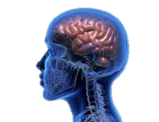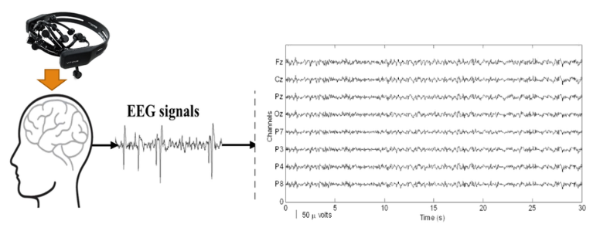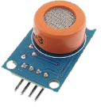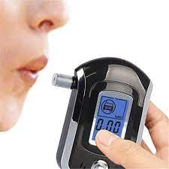

**DETECTORS FOR ALCOHOL**

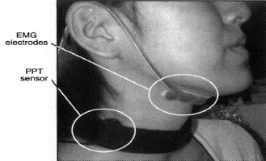

INDICATION

&

IGNISION UNIT OF BIKE

***Fig 3.1: Proposed System***

**CHAPTER 4**

**SYSTEM DESIGN**

1. **. BLOCK DIAGRAM**

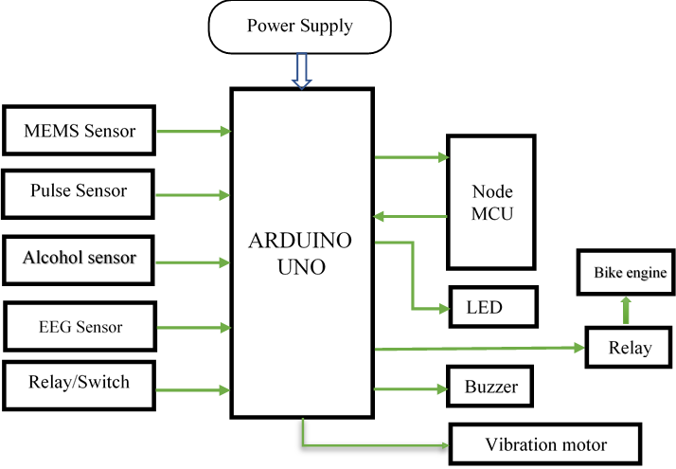

* 1. **BLOCK DIAGRAM DESCRIPTION**

The system consists of an Eye Blink Sensor that detects the blinking of the eye and a MEMS Sensor that detects the motion and orientation of the helmet. These sensors are connected to the Arduino board, which acts as the main controller for the system. The Arduino board collects data from the sensors and sends it to the Node MCU board. The Node MCU board is responsible for connecting to the internet via Wi-Fi and sending data to the cloud. The processing block analyzes the sensor data and determines whether the user is feeling drowsy or not. If the user is feeling drowsy, the Vibration Motor is activated to alert the user. The Relay is used to control the DC Motor, which is used to adjust the position of the helmet if the user is tilting their head. Finally, the Buzzer/LED is activated to give an audible/visual alert to the user.

* 1. **SYSTEM SPECIFICATION**

The requirements specification is a technical specification of requirements for the software products. It is the first step in the requirements analysis process it lists the requirements of a particular software system and hardware system including functional, performance and requirements. The requirements also provide usage scenarios from a user, an operational and an administrative perspective. The purpose of software requirements specification is to provide a detailed overview of the software project, its parameters and goals. This describes the project target doctor and the patient interface, hardware and software requirements. It defines how the patient, doctor see the system and its functionality.

**CHAPTER 5**

**SYSTEM REQUIREMENT**

1. **HARDWARE REQUIREMENT**

**5.1.1. ARDUINO**

Arduino is an open-source hardware and [software](https://en.wikipedia.org/wiki/Open-source_software) company, project, and user community that designs and manufactures [single-board microcontrollers](https://en.wikipedia.org/wiki/Single-board_microcontroller) and [microcontroller](https://en.wikipedia.org/wiki/Microcontroller) kits for building digital devices. Its hardware products are licensed under a [CC BY-SA license](https://en.wikipedia.org/wiki/Creative_Commons_license), while software is licensed under the [GNU Lesser General Public License](https://en.wikipedia.org/wiki/GNU_Lesser_General_Public_License) (LGPL) or the [GNU General Public License](https://en.wikipedia.org/wiki/GNU_General_Public_License) (GPL), permitting the manufacture of Arduino boards and software distribution by anyone. Arduino boards are available commercially from the official website or through authorized distributors.

Arduino board designs use a variety of [microprocessors](https://en.wikipedia.org/wiki/Microprocessor) and controllers. The boards are equipped with sets of digital and analog [input/output](https://en.wikipedia.org/wiki/Input/output) (I/O) pins that may be interfaced to various expansion boards ('shields') or [breadboards](https://en.wikipedia.org/wiki/Breadboards) (for prototyping) and other circuits. The boards feature serial communications interfaces, including [Universal Serial Bus](https://en.wikipedia.org/wiki/Universal_Serial_Bus) (USB) on some models, which are also used for loading programs. The microcontrollers can be programmed using the [C](https://en.wikipedia.org/wiki/C_(programming_language)) and [C++](https://en.wikipedia.org/wiki/C%2B%2B) [programming languages](https://en.wikipedia.org/wiki/Programming_language), using a standard API which is also known as the Arduino language, inspired by the [Processing language](https://en.wikipedia.org/wiki/Processing_(programming_language)) and used with a modified version of the Processing IDE. In addition to using traditional [compiler](https://en.wikipedia.org/wiki/Compiler) [toolchains](https://en.wikipedia.org/wiki/Toolchains), the Arduino project provides an [integrated development environment](https://en.wikipedia.org/wiki/Integrated_development_environment) (IDE) and a command line tool developed in [Go](https://en.wikipedia.org/wiki/Go_(programming_language)).

Most Arduino boards consist of an [Atmel](https://en.wikipedia.org/wiki/Atmel) 8- bit AVRmicrocontroller (ATmega8,[[28]](https://en.wikipedia.org/wiki/Arduino#cite_note-28) ATmega168, [ATmega328](https://en.wikipedia.org/wiki/ATmega328),ATmega1280, or ATmega2560) with varying amounts of flash memory, pins, and features.[[29]](https://en.wikipedia.org/wiki/Arduino#cite_note-29) The 32-bit [Arduino Due](https://en.wikipedia.org/wiki/Arduino_Due), based on the Atmel [SAM3X8E](https://en.wikipedia.org/wiki/Atmel_ARM-based_processors#SAM_3) was introduced in 2012.[[30]](https://en.wikipedia.org/wiki/Arduino#cite_note-30) The boards use single or double-row pins or female headers that facilitate connections for programming and incorporation into other circuits. These may connect with add-on modules termed shields. Multiple and possibly stacked shields may be individually addressable via an [I2C](https://en.wikipedia.org/wiki/I2C) [serial bus](https://en.wikipedia.org/wiki/Serial_bus). Most boards include a 5 V [linear regulator](https://en.wikipedia.org/wiki/Linear_regulator) and a 16 MHz [crystal oscillator](https://en.wikipedia.org/wiki/Crystal_oscillator) or [ceramic resonator](https://en.wikipedia.org/wiki/Ceramic_resonator). Some designs, such as the LilyPad,[[31]](https://en.wikipedia.org/wiki/Arduino#cite_note-31) run at 8 MHz and dispense with the onboard voltage regulator due to specific form-factor restrictions.

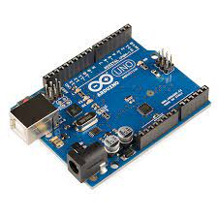

***Fig 5.1: Arduino***

Arduino microcontrollers are pre-programmed with a [boot loader](https://en.wikipedia.org/wiki/Boot_loader) that simplifies uploading of programs to the on-chip [flash memory](https://en.wikipedia.org/wiki/Flash_memory). The default bootloader of the Arduino Uno is the Optiboot bootloader.[[32]](https://en.wikipedia.org/wiki/Arduino#cite_note-32) Boards are loaded with program code via a serial connection to another computer. Some serial Arduino boards contain a level shifter circuit to convert between [RS-232](https://en.wikipedia.org/wiki/RS-232) logic levels and [transistor–transistor logic](https://en.wikipedia.org/wiki/Transistor%E2%80%93transistor_logic) (TTL) level signals. Current Arduino boards are programmed via [Universal Serial Bus](https://en.wikipedia.org/wiki/Universal_Serial_Bus) (USB), implemented using USB-to-serial adapter chips such as the [FTDI](https://en.wikipedia.org/wiki/FTDI) FT232. Some boards, such as later-model Uno boards, substitute the [FTDI](https://en.wikipedia.org/wiki/FTDI) chip with a separate AVR chip containing USB-to-serial firmware, which is reprogrammable via its own [ICSP](https://en.wikipedia.org/wiki/In-system_programming) header. Other variants, such as the Arduino Mini and the unofficial Boarduino, use a detachable USB-to-serial adapter board or cable, [Bluetooth](https://en.wikipedia.org/wiki/Bluetooth) or other methods. When used with traditional microcontroller tools, instead of the Arduino IDE, standard AVR [in-system programming](https://en.wikipedia.org/wiki/In-system_programming) (ISP) programming is used.

**5.1.2. NODE MCU**

NodeMCU is an open-source Lua based firmware and **development board** specially targeted for IoT based Applications. It includes firmware that runs on the ESP8266 Wi-Fi SoC from Espressif Systems, and hardware which is based on the ESP-12 module

### **Programming NodeMCU ESP8266 with Arduino IDE**

The NodeMCU Development Board can be easily programmed with Arduino IDE since it is easy to use.

Programming NodeMCU with the Arduino IDE will hardly take 5-10 minutes. All you need is the Arduino IDE, a USB cable and the NodeMCU board itself. You can check this Getting Started Tutorial for NodeMCU to prepare your Arduino IDE for NodeMCU.

### ESP8266 Arduino Core

As [Arduino.cc](https://en.wikipedia.org/wiki/Arduino) began developing new MCU boards based on non-[AVR](https://en.wikipedia.org/wiki/AVR_microcontrollers) processors like the ARM/SAM MCU and used in the Arduino Due, they needed to modify the [Arduino IDE](https://en.wikipedia.org/wiki/Arduino_IDE) so that it would be relatively easy to change the IDE to support alternate toolchains to allow Arduino C/C++ to be compiled for these new processors. They did this with the introduction of the Board Manager and the SAM Core. A "core" is the collection of software components required by the Board Manager and the Arduino IDE to compile an Arduino C/C++ source file for the target MCU's machine language. Some ESP8266 enthusiasts developed an Arduino core for the ESP8266 WiFi SoC, popularly called the "ESP8266 Core for the Arduino IDE".This has become a leading software development platform for the various ESP8266-based modules and development boards, including NodeMCUs.

NodeMCU is an open-source LUA based firmware developed for the ESP8266 wifi chip. By exploring functionality with the ESP8266 chip, NodeMCU firmware comes with the ESP8266 Development board/kit i.e. NodeMCU Development board.

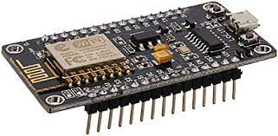

***Fig 5.2: NODE MCU***

**NodeMCU Development Board/kit v1.0 (Version2)**

For more information about NodeMCU Boards available in the market refer to NodeMCU Development Boards NodeMCU Dev Kit has **Arduino like** Analog (i.e. A0) and Digital (D0-D8) pins on its board. It supports serial communication protocols i.e. UART, SPI, I2C, etc.

Using such serial protocols we can connect it with serial devices like I2C enabled LCD display, Magnetometer HMC5883, MPU-6050 Gyro meter + Accelerometer, RTC chips, GPS modules, touch screen displays, SD cards, etc.

**NodeMCU with Arduino IDE**

Here is another way of developing NodeMCU with a well-known IDE i.e. Arduino IDE. We can also develop applications on NodeMCU using the Arduino development environment. This makes it easy for Arduino developers than learning a new language and IDE for NodeMCU. For more information about how to write Arduino sketch for NodeMCU refer to Getting started with NodeMCU using Arduino IDE

**NodeMCU ESP8266 Specifications & Features**

* Microcontroller: Tensilica 32-bit RISC CPU Xtensa LX106
* Operating Voltage: 3.3V
* Input Voltage: 7-12V
* Digital I/O Pins (DIO): 16
* Analog Input Pins (ADC): 1
* UARTs: 1
* SPIs: 1
* I2Cs: 1
* Flash Memory: 4 MB
* SRAM: 64 KB
* Clock Speed: 80 MHz
* USB-TTL based on CP2102 is included onboard, Enabling Plug n Play
* PCB Antenna
* Small Sized module to fit smartly inside your IoT projects

**5.1.3. END STOP SWITCH**

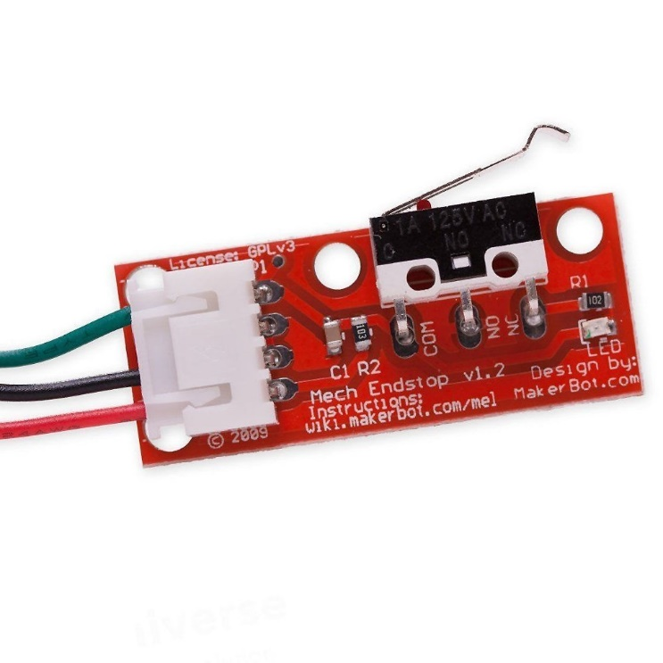

***Fig 5.3: END STOP SWITCH***

## If an end stop switch is fixed in a helmet to detect a fall, it can provide an additional safety feature by triggering an alert or notifying others when the rider experiences a fall or collision. Here's how such a setup could work:

## End stop switch installation: The end stop switch is securely mounted within the helmet, ideally in a position where it can detect sudden movements or impacts. This can be achieved by attaching the switch to the internal structure of the helmet or integrating it into the padding or lining.

## Wiring and connection: The end stop switch is connected to an electronic circuit or control module, which can be located within the helmet or in a separate unit. The wiring should be safely routed to avoid interfering with the rider's comfort or safety.

## Fall detection algorithm: The control module incorporates a fall detection algorithm that monitors the state of the end stop switch. This algorithm analyzes the signals from the switch to distinguish between regular movements and the distinctive patterns associated with a fall or collision.

## Triggering alerts or notifications: When the fall detection algorithm identifies a fall or collision based on the end stop switch's signals, it triggers an alert or notification system. This can involve activating lights, sounding an alarm, or wirelessly transmitting a distress signal to a paired device or external monitoring system.

## Emergency response and assistance: The triggered alerts or notifications can be used to notify nearby individuals or emergency services about the rider's fall. This enables a prompt response and potential assistance to the injured rider.

* + 1. **LCD**

LCD (Liquid Crystal Display) is the innovation utilized in scratch pad shows and other littler PCs. Like innovation for light-producing diode (LED) and gas-plasma, LCDs permit presentations to be a lot more slender than innovation for cathode beam tube (CRT). LCDs expend considerably less power than LED shows and gas shows since they work as opposed to emanating it on the guideline of blocking light.

A LCD is either made with a uninvolved lattice or a showcase network for dynamic framework show. Likewise alluded to as a meager film transistor (TFT) show is the dynamic framework LCD. The uninvolved LCD lattice has a matrix of conductors at every crossing point of the network with pixels. Two conductors on the lattice send a current to control the light for any pixel. A functioning framework has a transistor situated at every pixel crossing point, requiring less current to control the luminance of a pixel.

[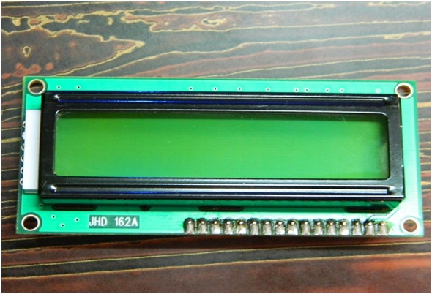](http://www.circuitstoday.com/wp-content/uploads/2012/02/LCD-Display-Front-Side.jpg)

***Fig 5.4: LCD – Front View***

A 16x2 LCD show is an essential module that is generally utilized in various gadgets and circuits. These modules more than seven sections and other multi fragment LEDs are liked. The reasons being: LCDs are affordable; effectively programmable; have no restriction of showing exceptional and even custom characters (not at all like in seven fragments), movements, etc.

[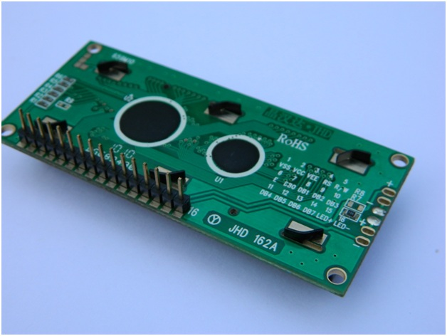](http://www.circuitstoday.com/wp-content/uploads/2012/02/lcd-display-back-side.jpg)

***Fig 5.5: LCD – Back View***

**Pin Diagram:**

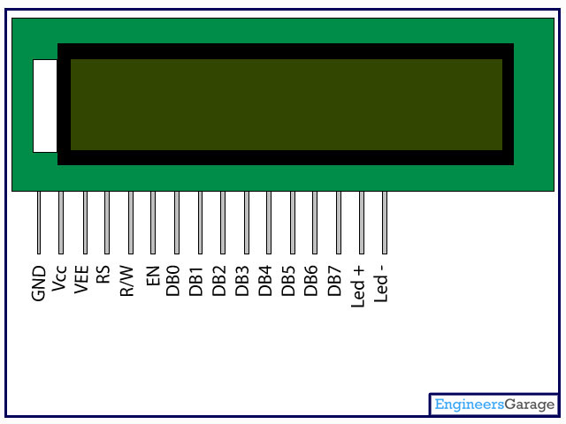

***Fig 5.6: Pin Diagram***

**Pin Description:**

|  |  |  |
| --- | --- | --- |
| **Pin No** | **Function** | **Name** |
| 1 | Ground (0V) | Ground |
| 2 | Supply voltage; 5V (4.7V – 5.3V) | Vcc |
| 3 | Contrast adjustment; through a variable resistor | VEE |
| 4 | Selects command register when low; and data register when high | Register Select |
| 5 | Low to write to the register; High to read from the register | Read/write |
| 6 | Sends data to data pins when a high to low pulse is given | Enable |
| 7 | 8-bit data pins | DB0 |
| 8 | DB1 |
| 9 | DB2 |
| 10 | DB3 |
| 11 | DB4 |
| 12 | DB5 |
| 13 | DB6 |
| 14 | DB7 |
| 15 | Backlight VCC (5V) | Led+ |
| 16 | Backlight Ground (0V) | Led- |

**Data/Signals/Execution of LCD**

Now that was all about the signals and the hardware. Let us come to data, signals and execution.

Two types of signals are accepted by LCD, one is data and one is control. The LCD module recognizes these signals from the RS pin status. By pulling the R / W pin high, data can now also be read from the LCD display. Once the E pin has been pulsed, the LCD display reads and executes data at the falling edge of the pulse, the same for the transmission case.

It takes 39-43μS for the LCD display to place a character or execute a command. It takes 1.53ms to 1.64ms except for clearing display and searching for cursor to the home position.

**[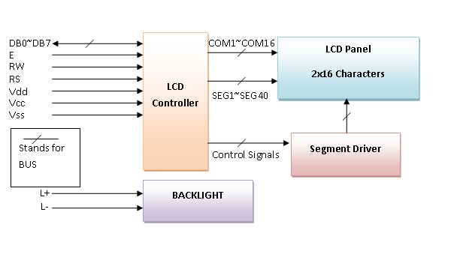](http://www.circuitstoday.com/wp-content/uploads/2012/02/LCD-Display-Block-Diagram.png)**

Any attempt to send data before this interval may result in failure in some devices to read data or execute the current data. Some devices compensate for the speed by storing some temporary registers with incoming data.

There are two RAMs for LCD displays, namely DDRAM and CGRAM. DDRAM registers the position in which the character would be displayed in the ASCII chart. Each DDRAM byte represents every single position on the display of the LCD.

The DDRAM information is read by the LCD controller and displayed on the LCD screen. CGRAM enables users to define their personalized characters. Address space is reserved for users for the first 16 ASCII characters.

Users can easily display their custom characters on the LCD screen after CGRAM has been set up to display characters.

**Control and display commands**

|  |  |  |  |  |  |  |  |  |  |  |  |  |
| --- | --- | --- | --- | --- | --- | --- | --- | --- | --- | --- | --- | --- |
| **Instruction** | **Instruction Code** | | | | | | | | | | **Instruction Code Description** | **Execution time** |
| RS | R/W | DB7 | DB6 | DB5 | DB4 | DB3 | DB2 | DB1 | DB0 |
| Read Data From RAM | 1 | 1 | D7 | D6 | D5 | D4 | D3 | D2 | D1 | D0 | Read data from internal RAM | 1.53-1.64ms |
| Write data to RAM | 1 | 0 | D7 | D6 | D5 | D4 | D3 | D2 | D1 | D0 | Write data into internal RAM (DDRAM/CGRAM) | 1.53-1.64ms |
| Busy flag & Address | 0 | 1 | BF | AC6 | AC5 | AC4 | AC3 | AC2 | AC1 | AC0 | Busy flag (BF: 1→ LCD Busy) and contents of address counter in bits AC6-AC0. | 39 µs |
| Set DDRAM Address | 0 | 0 | 1 | AC6 | AC5 | AC4 | AC3 | AC2 | AC1 | AC0 | Set DDRAM address in address counter. | 39 µs |
| Set CGRAM Address | 0 | 0 | 0 | 1 | AC5 | AC4 | AC3 | AC2 | AC1 | AC0 | Set CGRAM Address in address counter. | 39 µs |
| Function Set | 0 | 0 | 0 | 0 | 1 | DL | N | F | X | X | Set interface data length (DL: 4bit/8bit), Numbers of display line (N: 1-line/2-line) display font type (F:0→ 5×8 dots, F:1→ 5×11 dots) | 39 µs |
| Cursor or Display Shift | 0 | 0 | 0 | 0 | 0 | 1 | S/C | R/L | X | X | Set cursor moving and display shift control bit, and the direction without changing DDRAM data | 39 µs |
| Display & Cursor On/Off | 0 | 0 | 0 | 0 | 0 | 0 | 1 | D | C | B | Set Display(D),Cursor(C) and cursor blink(b) on/off control | 39 µs |
| Entry Mode Set | 0 | 0 | 0 | 0 | 0 | 0 | 0 | 1 | I/D | SH | Assign cursor moving direction and enable shift entire display. | 0µs |
| Return Home | 0 | 0 | 0 | 0 | 0 | 0 | 0 | 0 | 1 | X | Set DDRAM Address to “00H” from AC and return cursor to its original position if shifted. | 43µs |
| Clear Display | 0 | 0 | 0 | 0 | 0 | 0 | 0 | 0 | 0 | 1 | Write “20H” to DDRAM and set DDRAM Address to “00H” from AC | 43µs |

**5.1.5. GAS SENSOR**

## MQ3 Alcohol Sensor

## MQ3 is one of the most commonly used sensors in the MQ sensor series. It is a Metal Oxide Semiconductor (MOS) type of sensor. Metal oxide sensors are also known as ****Chemiresistors****, because sensing is based on the change of resistance of the sensing material when exposed to alcohol. So by placing it in a simple voltage divider network, alcohol concentrations can be detected.

## MQ3 alcohol sensor works on 5V DC and draws around 800mW. It can detect Alcohol concentrations anywhere from 25 to 500 ppm.MQ3 is a heater-driven sensor. That’s why it is enclosed in two layers of fine stainless steel mesh called an ****Anti-explosion network****. It ensures that heater element inside the sensor will not cause an explosion, as we are sensing flammable gas (alcohol).

## Here are the complete specifications

|  |  |
| --- | --- |
| ***MQ3 Alcohol sensor specifications*** | |
| Operating voltage | 5V |
| Load resistance | 200 KΩ |
| Heater resistance | 33Ω ± 5% |
| Heating consumption | <800mw |
| Sensing Resistance | 1 MΩ – 8 MΩ |
| Concentration Scope | 25 – 500 ppm |
| Preheat Time | Over 24 hour |

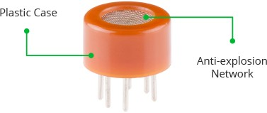

***Fig 5.7: Outer View Of Sensor***

It also provides protection for the sensor and filters out suspended particles so that only gaseous elements are able to pass inside the chamber.

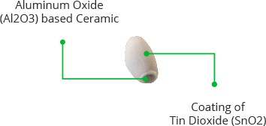

***Fig 5.8: Inner View Of Sensor***

The tubular sensing element is made up of Aluminum Oxide (AL2O3) based ceramic and has a coating (fig 5.8)of Tin Dioxide (SnO2). The Tin Dioxide is the most important material being sensitive towards alcohol. However, the ceramic substrate only increases the heating efficiency and ensures that the sensor area is continuously heated to the working temperature.

So, to summarize, the Nickel-Chromium coil and Aluminum Oxide based ceramic forms a Heating System; while Platinum wires and coating of Tin Dioxide forms a Sensing System.

## MQ3 Alcohol Sensor Module Hardware Overview

Since the MQ3 alcohol sensor is not breadboard compatible, we recommend this handy little breakout board. It’s very easy to use and comes with two different outputs. It not only provides a binary indication of the presence of alcohol but also an analog representation of its concentration in air.

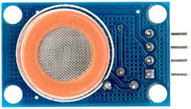

***Fig 5.9: MQ3 Alcohol Sensor***

The analog output voltage provided by the sensor (at AO pin) varies in proportion to the alcohol concentration. The higher the alcohol concentration in the air, the higher the output voltage; Whereas lower concentration gives lower output voltage. The following animation shows the relationship between alcohol concentration and output voltage.The same analog signal is fed to a LM393 High Precision Comparator to digitize it and is made available at the Digital Output (DO) pin.

**5.1.6. VIBRATION MOTOR**

The first vibrator motor was developed in the year 1960 which are used for product massaging, but [the motor](https://www.elprocus.com/synchronous-motor-working-principle-types/) development has taken a new twist in the year 1990 as users need vibration calls on their cell phones. At present, the motor designers, as well as users, have discovered from mobile phones, that mobile alerting with vibration is an outstanding technique to alert mobile operators to an incident. Nowadays, small vibrating motors are used in a wide range of applications like scanners, tools, GPS trackers, control sticks, and medical instruments. These motors are also the main actuators for force feedback which is an economical method to enhance the value of a product.

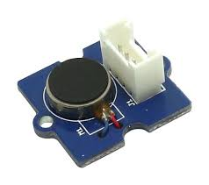

***Fig 5.10: Vibration Motor***

Vibration motor is a coreless [DC motor](https://www.elprocus.com/dc-motor-basics-types-application/) and the size of this motor is compact. The main purpose of this motor is to alert the user from receiving the call by without sound/vibrating. These motors are applicable for different applications like pagers, handsets, cell phones, etc. The main feature of this motor is, it has magnetic properties, lightweight, and motor size is small. Based on these features, the motor performance is highly consistent. The configuration of these [motors](https://www.elprocus.com/different-types-of-servo-motors-dc-servo-motor-and-ac-servo-motor/) can be done in two varieties one is coin model and another one is a cylinder model. The vibrator motor specifications mainly include type, max operating torque, max.centrifugal force, weight range, rated current and output.

**5.1.7.PULSE SENSOR**

A Pulse Sensor is a type of sensor that is used to detect the heart rate of a person. It works by shining a light through the skin and measuring the changes in the light as it passes through the blood vessels. The changes in the light are caused by the pulsing of blood through the vessels, and this information can be used to determine the heart rate of the person. Pulse Sensors are commonly worn on the finger or earlobe and are used in various applications such as fitness tracking devices, medical devices, and other applications where heart rate monitoring is important. The output of the Pulse Sensor can be connected to a microcontroller such as an Arduino, which can then be used to display the heart rate or to trigger an alert if the heart rate exceeds a certain threshold. The use of Pulse Sensors in health monitoring systems can provide important information about the cardiovascular health of the individual and can help in the early detection and prevention of cardiovascular diseases.

**Heart Rate Range**: Pulse sensors typically have a specified heart rate range within which they can accurately measure the heart rate. The range may vary depending on the sensor's design and intended application. For example, a typical range might be around 30-220 beats per minute (bpm).

**Sampling Rate:** The sampling rate refers to the frequency at which the pulse sensor measures the heart rate. It represents how many heart rate measurements are taken per second. Common sampling rates range from 10 Hz to 1000 Hz. Higher sampling rates generally provide more accurate and real-time heart rate data.

**Signal Resolution:** The signal resolution refers to the smallest detectable change in the heart rate measurement. It determines the precision of the pulse sensor. Higher resolution allows for more accurate and detailed heart rate readings.

**Output Format:** Pulse sensors can provide heart rate data in different output formats, depending on the sensor and its interface. Some sensors provide raw analog voltage signals that require further processing, while others offer processed digital outputs, such as the heart rate value directly in bpm or through digital protocols like I2C or SPI.

The heart rate of the biker can be monitored along with the eye blink sensor and MEMS sensor to get a more accurate assessment of the biker's level of fatigue and drowsiness. If the biker's heart rate exceeds a certain threshold, it can be an indication of high stress or physical exhaustion. This information can be used to trigger an alert or to adjust the vibration motor intensity or DC motor position to help the biker maintain a safe driving posture. Overall, incorporating a Pulse Sensor can enhance the accuracy and effectiveness of the drowsiness and fatigue detection system for bikers.

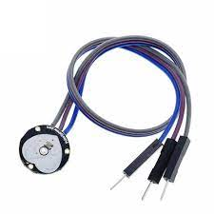

***Fig 5.11: Pulse Sensor***

The range of a Pulse Sensor refers to the range of heart rates that the sensor is capable of detecting. Typically, Pulse Sensors can detect heart rates ranging from 30 beats per minute (BPM) to 220 BPM. However, the actual range may vary depending on the specific sensor and its design. In general, Pulse Sensors are capable of detecting heart rates within a relatively wide range and can be used to monitor the heart rate of individuals with different levels of fitness and activity levels.

**It's important to note that pulse sensors have limitations and considerations:**

**Accuracy:** The accuracy of pulse sensors can be influenced by factors such as sensor placement, skin conditions, motion artifacts, and the quality of signal processing algorithms. Calibration and proper sensor positioning are critical to obtaining accurate heart rate measurements.

**Sensitivity:** The sensitivity of the pulse sensor may vary between individuals. Factors such as skin tone, blood circulation, and ambient light conditions can affect the sensor's performance.

**Compatibility:** Pulse sensors often require compatibility with specific devices or platforms, such as Arduino boards, microcontrollers, or smartphones, to interface with and process the obtained data.

**Signal Interfaces:**

Analog output: Some pulse sensors provide analog voltage output that corresponds to the detected heart rate. This analog signal can be directly connected to an analog-to-digital converter (ADC) for further processing.

Digital output: Many pulse sensors feature digital communication interfaces, such as I2C (Inter-Integrated Circuit) or SPI (Serial Peripheral Interface). These interfaces allow for easy integration with microcontrollers, Arduino boards, or other digital systems.

**5.1.8. MEMS SENSOR**

MEMS (Microelectromechanical Systems) Sensor is a type of motion sensor that detects the motion, orientation, and other environmental factors such as temperature and pressure. MEMS sensors are commonly used in various applications such as smartphones, gaming devices, and automotive systems. The MEMS sensor used in the above project for drowsiness and fatigue detection for bikers is most likely an accelerometer or a gyroscope. An accelerometer can detect the changes in acceleration or velocity, while a gyroscope can detect the changes in orientation. The MEMS sensor provides information about the position and motion of the helmet, which can be used to detect if the user is tilting their head or if the helmet is moving in an abnormal way. This information is used in combination with the Eye Blink Sensor to determine if the user is feeling drowsy or fatigued and trigger an alert if necessary. Overall, the MEMS Sensor is a crucial component in the drowsiness and fatigue detection system for bikers.

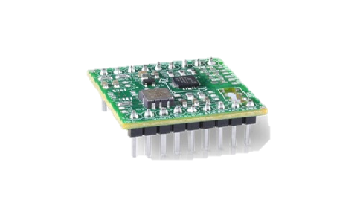

***Fig 5.12:MEMS Sensor***

**Working Principle:**

MEMS sensors utilize microfabrication techniques to create miniaturized mechanical structures, such as beams, diaphragms, or cantilevers, on a silicon substrate. These structures can be designed to respond to specific physical stimuli, such as acceleration, angular velocity, or pressure.

Real-time drowsiness and fatigue detection for bikers using a helmet, here are some possible ways to utilize MEMS sensors:

**Accelerometer**: An accelerometer MEMS sensor can be used to detect the acceleration and orientation of the biker's head. It can provide data on head movements, which can be analyzed to determine if the rider is experiencing fatigue-induced head nods or sudden movements associated with falling asleep.

**Gyroscope**: A gyroscope MEMS sensor can measure the angular velocity or rotation of the helmet. By monitoring the helmet's orientation changes, it can help identify abnormal head positions or tilts that could indicate drowsiness or loss of control.

**Pressure Sensor**: A pressure-sensitive MEMS sensor can be integrated into the helmet's padding or lining to detect changes in pressure caused by impacts or falls. If a significant impact is detected, it can trigger an alert or emergency response to ensure the safety of the biker.

**Temperature Sensor**: A temperature-sensitive MEMS sensor can monitor the temperature inside the helmet. By detecting an increase in temperature, it can help identify signs of excessive heat or discomfort, which could be associated with drowsiness or fatigue.

**Heart Rate Sensor**: Although not specifically a MEMS sensor, a heart rate sensor can be incorporated into the helmet or worn by the biker to monitor their heart rate. This can provide additional data to correlate with other measurements and help detect changes in heart rate patterns associated with fatigue or drowsiness.

In the context of the above project, the MEMS sensor is used to detect the motion and orientation of the helmet worn by the biker. This information is then used to determine if the user is tilting their head or if the helmet is moving in an abnormal way. By analyzing the motion and orientation of the helmet, the system can detect if the biker is nodding off or if they are becoming drowsy.

* An accelerometer is a type of MEMS sensor that can measure changes in acceleration or velocity. It can detect the changes in the movement of the helmet and is commonly used in various applications such as smartphones, gaming devices, and automotive systems. In the context of the above project, the accelerometer can detect the head nodding motion of the biker and trigger an alert if necessary.
* A gyroscope is another type of MEMS sensor that can detect changes in orientation. It can detect the changes in the orientation of the helmet and can be used to determine if the biker is tilting their head. By combining the data from the accelerometer and gyroscope, the system can provide a more accurate assessment of the biker's level of drowsiness and fatigue.
* Overall, the MEMS sensor is a crucial component in the drowsiness and fatigue detection system for bikers. It provides important information about the motion and orientation of the helmet, which can be used to detect if the biker is becoming drowsy and trigger an alert to prevent accidents.

**5.1.9.EEG SENSOR**

An EEG (Electroencephalogram) sensor is a type of biosensor that measures the electrical activity of the brain. It records the electrical signals generated by the neurons in the brain and converts them into digital signals that can be analyzed by a computer. EEG sensors are commonly used in medical applications to diagnose various neurological disorders such as epilepsy, sleep disorders, and brain injuries.

In the context of the above project for drowsiness and fatigue detection for bikers, an EEG sensor can be used to measure the brain waves of the biker. By monitoring the electrical activity of the brain, the system can determine if the biker is becoming drowsy or experiencing fatigue. The EEG sensor can detect the changes in the alpha and theta brain waves, which are associated with drowsiness and sleepiness.

However, it's worth noting that EEG sensors are relatively expensive and require significant processing power to analyze the data. They also require the sensors to be attached to the scalp, which can be inconvenient for the user and may interfere with the normal use of the helmet. Therefore, in the context of the above project, a more practical solution may be to use simpler and more cost-effective sensors such as the Eye Blink Sensor and MEMS sensor, which can provide similar functionality without the need for complex and expensive EEG sensors.

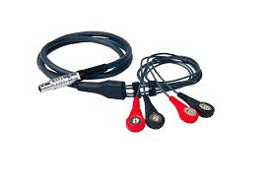

***Fig 5.13:EEG SENSOR***

**Working Principle:** EEG sensors capture the electrical signals generated by the brain's neurons. These signals, known as brainwaves, are the result of the communication and electrical activity within the brain.

The signals picked up by the EEG sensors are typically very low in amplitude and are easily influenced by noise from the environment, such as electrical interference from other devices. Therefore, special care must be taken to ensure that the EEG sensors are properly calibrated and that the signals are filtered to remove any noise that might interfere with the readings. EEG sensors are widely used in medical applications to diagnose various neurological disorders such as epilepsy, sleep disorders, and brain injuries. They can also be used in research to study brain function and to develop new therapies for neurological disorders.

**Brainwave Frequencies:** EEG sensors measure brainwave activity across different frequency bands, which are associated with different states of consciousness and mental activities. The main brainwave frequencies include:

* Delta (0.5-4 Hz): Deep sleep and unconscious states.
* Theta (4-8 Hz): Dreaming, meditation, and deep relaxation.
* Alpha (8-12 Hz): Relaxed wakefulness, daydreaming, and a calm mental state.
* Beta (12-30 Hz): Active thinking, problem-solving, and concentration.
* Gamma (30-100 Hz): Higher mental activities, perception, and cognitive processing.

**Signal Amplification and Processing**:

The electrical signals captured by the EEG sensors are typically weak, so they require amplification to increase their strength. The amplified signals are then filtered, removing noise and unwanted frequencies outside the range of interest. Additional signal processing techniques, such as artifact removal and feature extraction, may be applied to enhance the quality of the EEG data.

In the context of the above project, an EEG sensor can be used to provide an additional layer of data to the system, which can be used to further improve the accuracy of the drowsiness and fatigue detection. However, as mentioned earlier, EEG sensors can be relatively expensive and may require significant processing power to analyze the data. Therefore, a more practical solution may be to use simpler and more cost-effective sensors such as the Eye Blink Sensor and MEMS sensor.

* + 1. **POWER SUPPLY**

**Rectifier:**

A **rectifier** is an electrical device that [converts](https://en.wikipedia.org/wiki/Electric_power_conversion) [alternating current](https://en.wikipedia.org/wiki/Alternating_current) (AC), which periodically reverses direction, to [direct current](https://en.wikipedia.org/wiki/Direct_current) (DC), which flows in only one direction. The process is known as *rectification*, since it "straightens" the direction of current

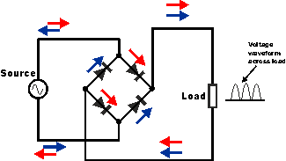

***Fig 5.14: Circuit of rectifier***

. Rectifiers have many uses, but are often found to serve as components of DC power supplies and direct power transmission systems with high voltage. Rectification can be used in roles other than direct current generation for use as a power source.

* 1. **Software Requirement**
     1. **Arduino IDE:**

**Arduino IDE**where IDE stands for Integrated Development Environment – An official software introduced by Arduino.cc, that is mainly used for writing, compiling and uploading the code in the Arduino Device. Almost all Arduino modules are compatible with this software that is an open source and is readily available to install and start compiling the code on the go.

* Arduino IDE is an open source software that is mainly used for writing and compiling the code into the Arduino Module.
* It is an official Arduino software, making code compilation too easy that even a common person with no prior technical knowledge can get their feet wet with the learning process.
* It is easily available for operating systems like MAC, Windows, and Linux and runs on the Java Platform that comes with inbuilt functions and commands that play a vital role for debugging, editing and compiling the code in the environment.
* A range of Arduino modules available including Arduino Uno, Arduino Mega, Arduino Leonardo, [Arduino Micro](https://www.theengineeringprojects.com/2018/09/introduction-to-arduino-micro.html) and many more.
* Each of them contains a microcontroller on the board that is actually programmed and accepts the information in the form of code.

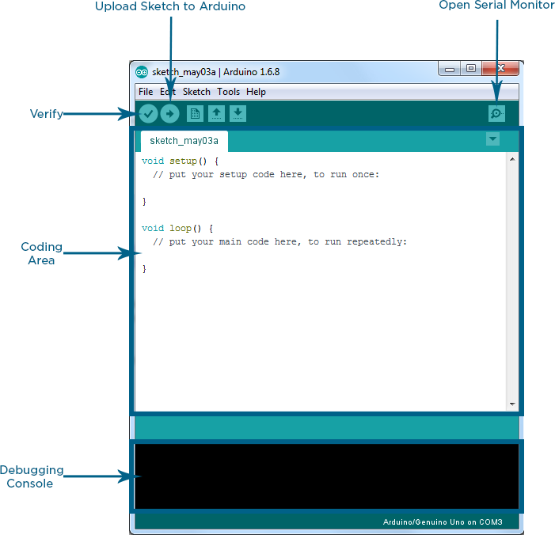

***Fig 5.15: Arduino IDE Interface***

* The main code, also known as a sketch, created on the IDE platform will ultimately generate a Hex File which is then transferred and uploaded in the controller on the board.
* The IDE environment mainly contains two basic parts: Editor and Compiler where former is used for writing the required code and later is used for compiling and uploading the code into the given Arduino Module.
* This environment supports both C and C++ languages.

**Libraries:**

Libraries are very useful for adding the extra functionality into the Arduino Module. There is a list of libraries you can add by clicking the Sketch button in the menu bar and going to Include Library.

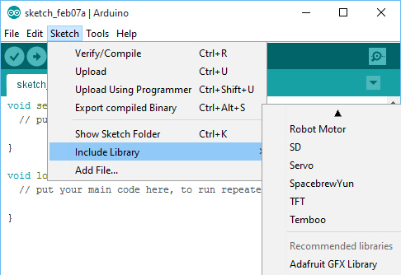

As you click the Include Library and Add the respective library it will on the top of the sketch with a #include sign. Suppose, I Include the EEPROM library, it will appear on the text editor as

#include <EEPROM.h>.

Most of the libraries are preinstalled and come with the Arduino software. However, you can also download them from the external sources.

**Making pins Input and output:**

The digitalRead and [digitalWrite](https://www.theengineeringprojects.com/2018/09/how-to-use-digitalwrite-arduino-command.html) commands are used for addressing and making the Arduino pins as an input and output respectively.

These commands are text sensitive i.e. you need to write them down the exact way they are given like digitalWrite starting with small “d” and write with capital “W”. Writing it down with Digitalwrite or digitalwrite won’t be calling or addressing any function.

**Select the board:**

In order to upload the sketch, you need to select the relevant board you are using and the ports for that operating system. As you click the Tools on the Menu, it will open like the figure below.

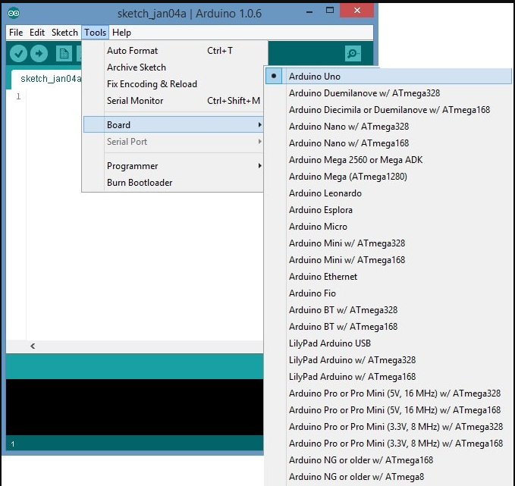

* Just go to the “Board” section and select the board you aim to work on. Similarly, COM1, COM2, COM4, COM5, COM7 or higher are reserved for the serial and USB board. You can look for the USB serial device in the ports section of the Windows Device Manager.

Following figure shows the COM4 that I have used for my project, indicating the Arduino Uno with COM4 port at the right bottom corner of the screen.

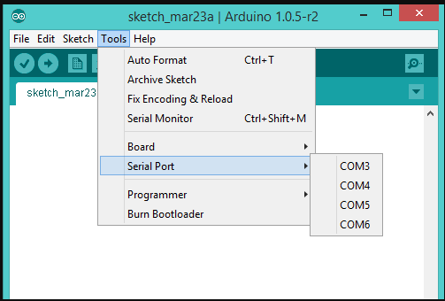

* After correct selection of both Board and Serial Port, click the verify and then upload button appearing in the upper left corner of the six button section or you can go to the Sketch section and press verify/compile and then upload.
* The sketch is written in the text editor and is then saved with the file extension .ino.

It is important to note that the recent Arduino Modules will reset automatically as you compile and press the upload button the IDE software, however, older version may require the physical reset on the board.

* Once you upload the code, TX and RX LEDs will blink on the board, indicating the desired program is running successfully.

**Note**: The port selection criteria mentioned above is dedicated for Windows operating system only, you can check this [Guide](https://www.arduino.cc/en/Guide/Environment) if you are using MAC or Linux.

* The amazing thing about this software is that no prior arrangement or bulk of mess is required to install this software, you will be writing your first program within 2 minutes after the installation of the IDE environment.
  + 1. **Programed by C/C++**

This System can be programmed using the Arduino Integrated Development Environment (IDE), which uses the C/C++ programming language. C is a high-level programming language that is used for system programming, embedded systems, and developing applications. The code for the Smart Cities Manhole Cover Management System can be written in C using the Arduino IDE, and it can be compiled and uploaded to the Arduino board using the IDE. The C code can be used to read data from the sensors, control the flow of data through the system, and send alerts and notifications when required.

In addition to the C language, the Arduino IDE also includes a range of libraries and examples that can be used to simplify the programming process and speed up development time. These libraries include functions for controlling the sensors, communicating with the GSM module, and controlling the buzzer, among others.

**CHAPTER 6**

**EXPERIMENTAL SETUP**

The experimental setup for the Arduino-based real-time drowsiness and fatigue detection system for bikers using a helmet includes various components that are connected to the Arduino board and programmed using the Arduino IDE. These components include an eye blink sensor, MEMS sensor, vibration motor, relay, DC motor, buzzer, and LED. The system is powered using a battery or by connecting it to the bike's electrical system and can monitor the biker's eyelid and head movements in real-time. It provides alerts if the biker is becoming drowsy or fatigued, and can also adjust the position of the helmet visor as needed to improve visibility and reduce glare. Additionally, the system can upload the data to the cloud using NodeMCU, where it can be analyzed and used to further improve the system's accuracy and performance.

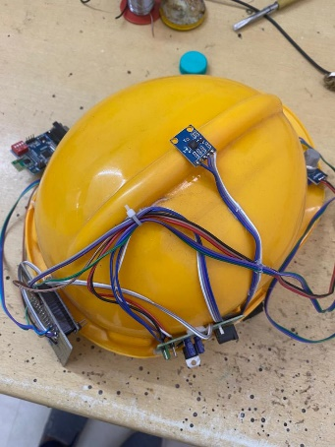

***Fig 6.1: Experimental Setup***

**EXPERIMENTAL HARDWARE RESULTS :**

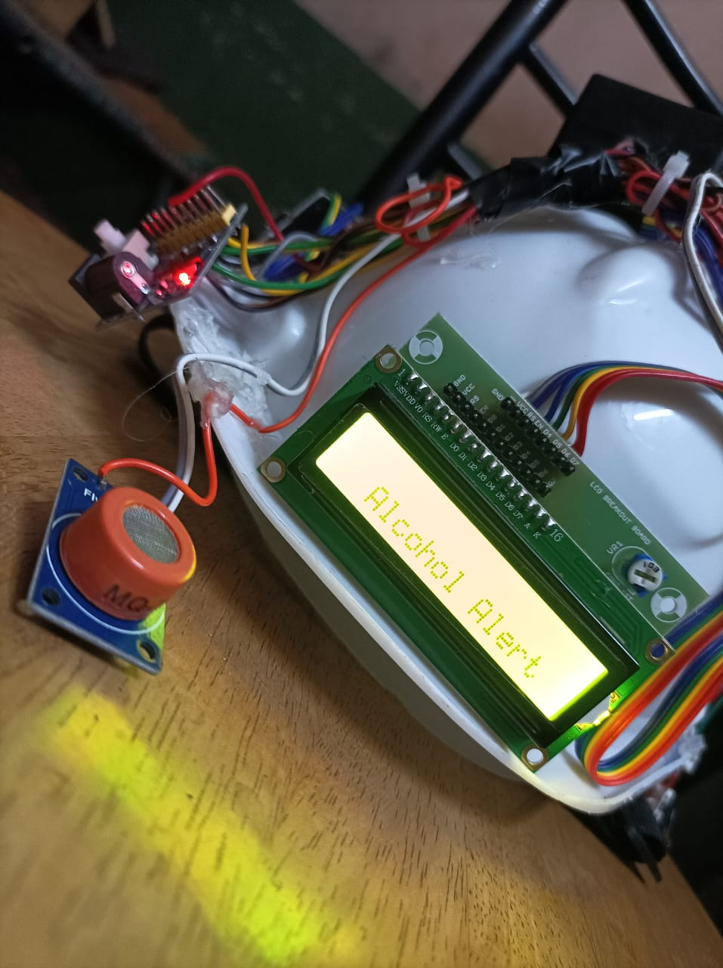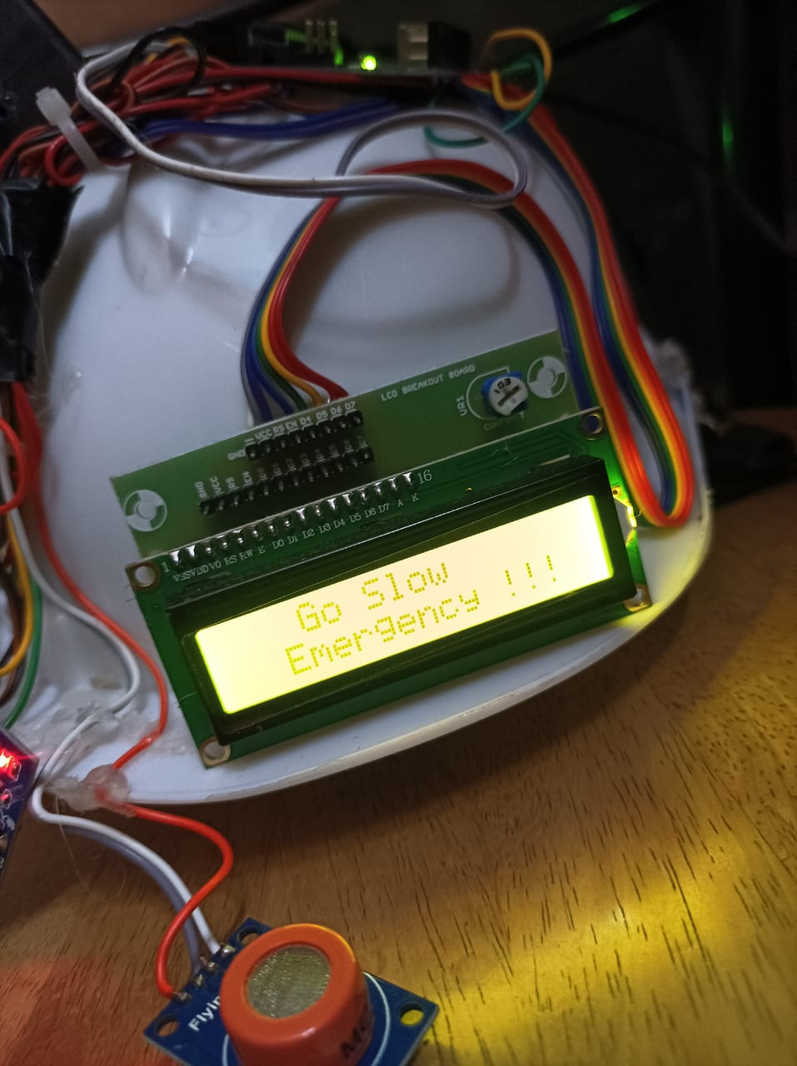

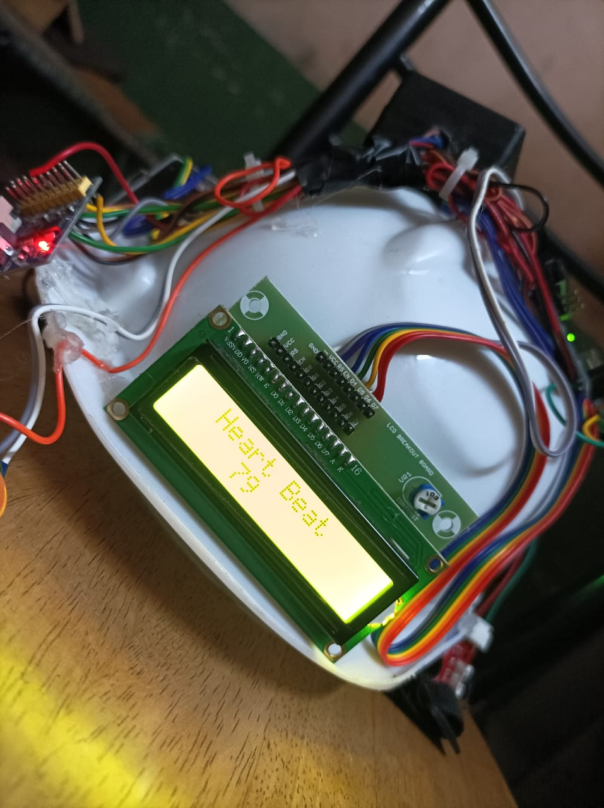

The Sensors can sense the data then send signal to microcontroller it will shown on display and send information to mobile or dashboard on UBIDOTS.

EXPERIMENTAL SOFTWARE RESULT:

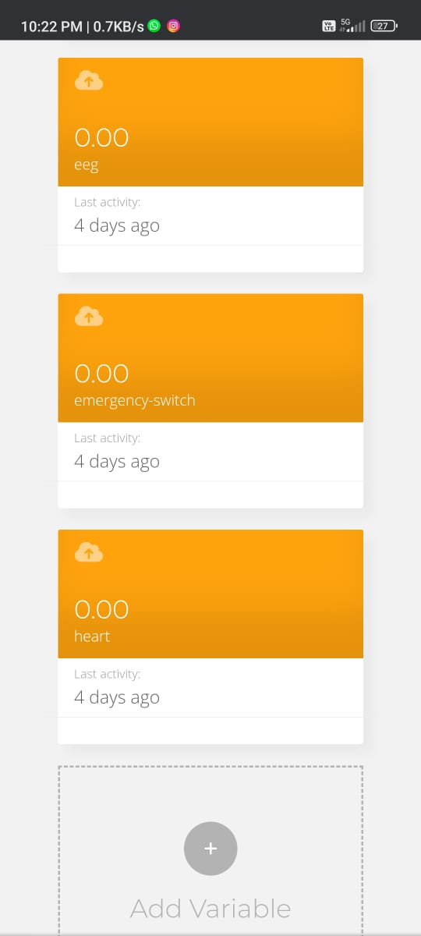

***Fig 6.2:Application Dashboard***

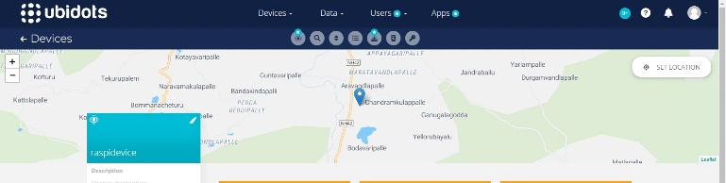

***Fig 6.3:Output Of Accident Location***

Communication with Ubidots: Utilize appropriate communication protocols, such as HTTP or MQTT, to send the accident location data from the Arduino to Ubidots. Ubidots provides APIs or libraries that you can use to integrate the communication functionality into your Arduino code.

Visualization: Create a dashboard in Ubidots to display the accident location data. Utilize map widgets provided by Ubidots or customize visual elements to show the accident locations on a map. You can configure the widget to retrieve the latitude and longitude values from the corresponding variables in your data source.

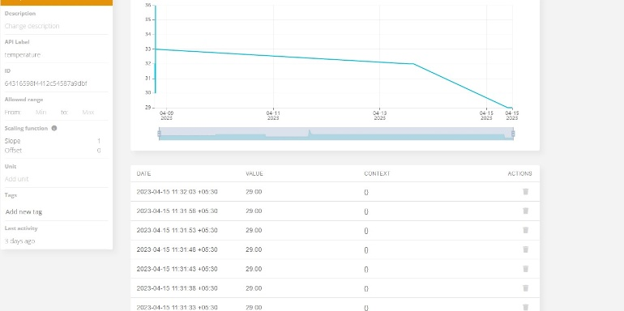

***Fig 6.4: Monitoring system output***

**CONCLUSION**

The driver drowsiness and alcohol detection system is used to detect the drowsiness of the driver and also detects the alcohol consumption of driver. If there is drowsiness or consumption then the motor of the car gets slowed down and the buzzer sounds until the eyes gets opened. The values of alcohol and the blink rate will be displayed in the serial monitor of the Arduino IDE IOT for intimate the parents or family member. This proposed system helps in finding drowsiness and alcohol detection using Arduino. This helps in avoiding many accidents. Further we extend this project by using webcam to detect the drowsiness of the driver.

**FUTURE SCOPE**

Machine Learning: Incorporating machine learning algorithms to the system can improve its efficiency and accuracy in detecting issues with the manhole cover. By analyzing data collected over time, machine learning models can predict potential problems before they occur. Energy Harvesting: Using energy harvesting technologies such as solar panels or kinetic energy harvesting can power the sensors and devices used in the system. This can reduce the dependence. Artificial Intelligence (AI) Integration: AI algorithms can be integrated with the system to analyze the data collected by the sensors and provide insights on trends and patterns.

**REFERENCE**

[1] Elzohairy Y (2008) Fatal and injury fatigue-related crashes on ontario’s roads: a 5-year review. In: Working together to understand driver fatigue: report on symposium proceedings, february 2008

[2] Dingus TA, Jahns SK, Horowitz AD, Knipling R (1998) Human factors design issues for crash avoidance systems. In: Barfield W, Dingus TA (eds) Human factors in intelligent transportation systems. Lawrence Associates, Mahwah, pp 55–93.

[3] Idrees, H., Warner, N., and Shah, M. (2014). Tracking In Dense Crowds Using Prominence And Neighborhood Motion Concurrence. Image And Vision Computing, 32(1):14–26. Yamamomo K, Higuchi, S Development of a drowsiness warning system. J, SocAutomotEng Jap 46:127–133

[5].K.C.Yowand,R.Cipolla,“FeatureBasedhumanfacedetection,“ImageVisio nComput., vol.15, no.9, 1997,pp.713–735.

[6].An Analysis of Viola Jones algorithm for face detection by Yi- QuinWang, University of Malaysia Phang, 2014,pp:15-20.

[7].Implementation of Voila Jones Algorithm by Ole HelvigJensen, university of Denmark, 2008,